**Multilayer Perceptron Using the CIFAR-10 Dataset**

Syed Haroon Perveez

1. Introduction:

A multilayer perceptron is the basic kind of a deep neural network an here we have altered various parameters of the CIFAR-10 dataset to come up with best model by providing different observations and provided further suggestions on how the accuracy of the model can be increased.

Observations:

Here I have note down 3 observations that we observed as a result of various permutations and combinations done on the parameters of the base code of the mlp.

**Observation 1:**

Number of epochs: 50

Batch size: 128

Network Configuration

1. Number of neurons in layer: Layer 1 – 1024, Layer 2 - 512
2. Number of layers: 2

Activation function: ReLU function

Dropout rates: 0.3

Here we notice the model is over-fitting as there is too much of validation loss. As the training loss decreases the validation loss increases with the number of epochs.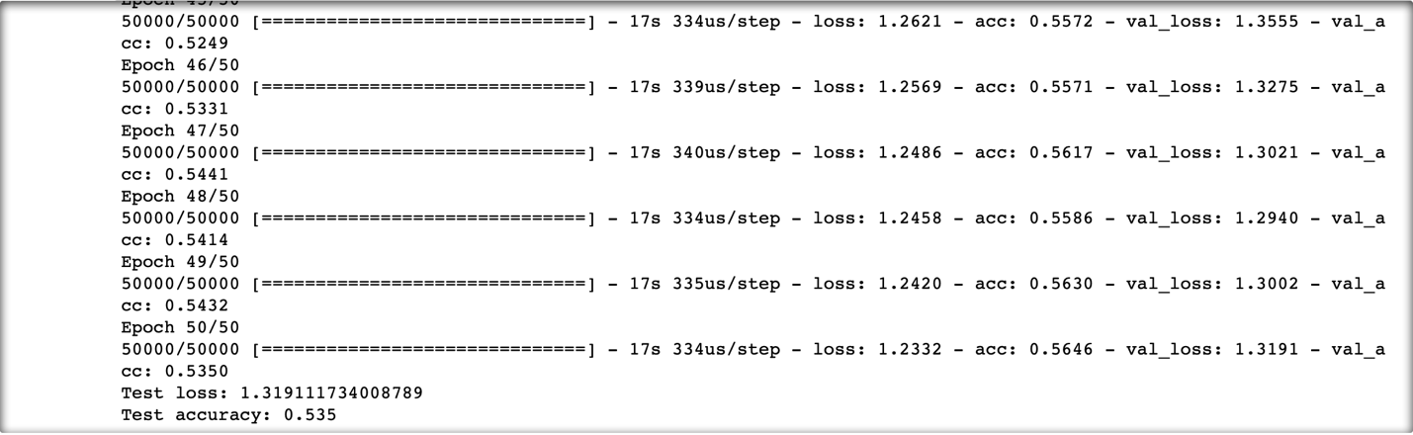



**Observation 2:**

Number of epochs: 75

Batch size: 128

Network Configuration

1. Number of neurons in layer: Layer 1 – 1024, Layer 2 –512, Layer 3 - 512
2. Number of layers: 3

Activation function: ReLU function

Dropout rates: 0.2

Here notice that the accuracy increases but with still there is overfitting





**Observation 3:**

Number of epochs: 30

Batch size: 512

Network Configuration

1. Number of neurons in layer: Layer 1 – 1024, Layer 2 –1024, Layer 3 – 512
2. Number of layers: 3

Activation function: ReLU function

Dropout rates: 0.2 first two layers and 0.1 for last layer





Here in this observation we can see three characteristics. Along the graph the validation is less than the training loss, after a few epochs it becomes equal to the training loss and after another few epochs, we observe over fitting in the model.

**Conclusion:**

After trying different combinations of parameters, I came up with the conclusion that increasing the density of the hidden layers, that is, increasing the number of neurons in the hidden layers increases the accuracy of the training data but it starts to overfit after a particular number of epochs. (approx. 45 epochs)

The best Model according to me is 2nd one which has training accuracy of 54.7(cutoff at 40 epochs) and validation accuracy at 52.9